4/19/2020

|  |
| --- |
| **PROFILE FILE 2020** |

KIBALITEK IS A START UP PROJECT MAJORING IN MOBILE APPLICATIONS AND ENTERPRISE DEVELOPMENT, LOCATED IN BUSIA MUNICIPALITY, UGANDA, EAST AFRICA, WITH A TEAM OF OVER 20 YOUNG DEVELOPERS MALE AND FEMALE. MALE AND FEMALE.



|  |  |
| --- | --- |
| KIBALITEK | KIBALITEK |

**KIBALITEK**

**PREPARING FOR THE FUTURE WITH TECHNOLOGY.**

**PROFILE FILE 2020**

P.O BOX 19, BUSIA UGANDA, EAST AFRICA.

[kibalitek@gmail.com](mailto:kibalitek@gmail.com)

[bwirephabiano939@gmail.com](mailto:bwirephabiano939@gmail.com)

+256754783752 / +256774555829 / +256750556129

JOE

CO-FOUNDER.

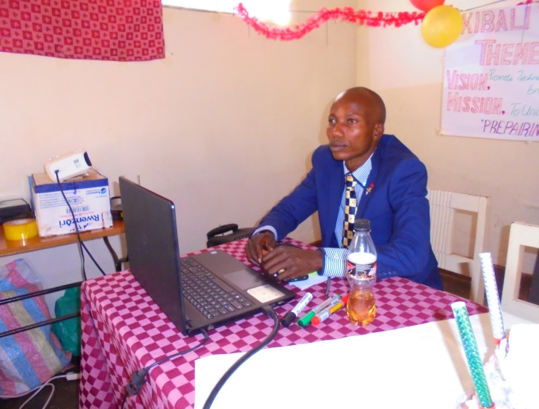 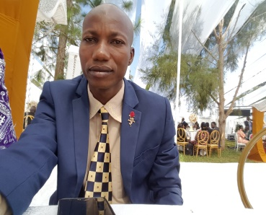

BWIRE PHABIANO

C.E O

Bwire is the CO-FOUNDER and CEO of KIBALITEK.

He holds a Bachelor’s degree in science with Education (Busitema University), a Diploma in secondary Education- Biology/ Chemistry(Kyambogo university), a Certificate in computer Education(Moi university Eldoret – Kenya) .

He started the idea of computer programming in March, 2019 with a friend called Joe living in the USA.

Bwire had taught and examined Bio/Chem for 10 years at secondary level.

He currently runs the project activities as the CEO.

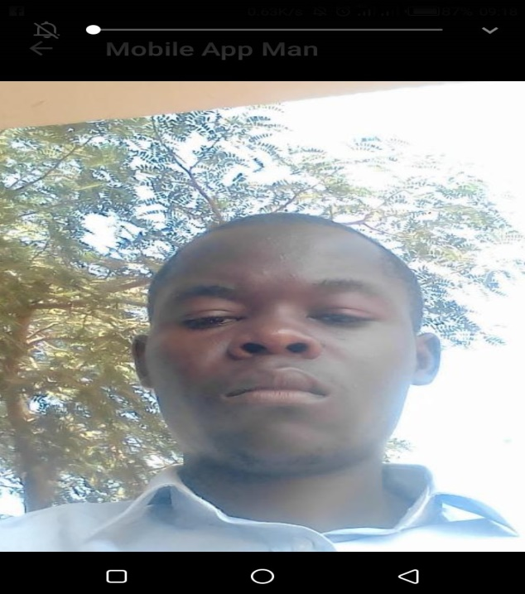

WAFULA NEWTON

PROGRAMS DIRECTOR

Wafula, is in charge of controlling all programming activities, posting project information to all platforms, youtube, play store, compiling all tutorials and distributing to the various teams, assessing the level of out put for each team and giving technical advise.

He reports to the CEO.

Newton is an undergraduate of bachelors in computer science( Makerere university).

Before joining Kibalitek, he worked with Diamond trust bank as a networking officer

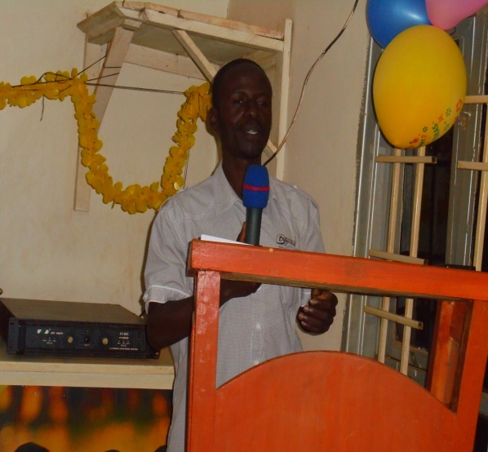 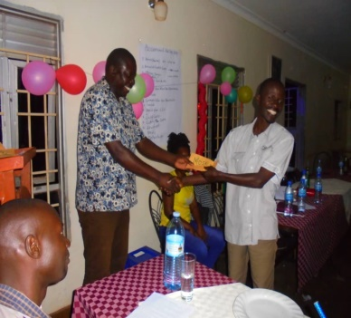

ODWORI MOSES

TEAM LEADER

Odwori is the team leader charged with responsibility of organizing sesssions and learning activities at kibalitek.

He holds a bachelor’s degree in education with economics( Makerere university).

He had earlier taught for 5 years in high schools before joining the team.



BALYEGISAWA MICHEAL

TEAM LEADER-JAVA

Mike, is in charge of organizing sessions for the web designing team who call themselves the

‘Java team”. He reports to the overall team leader on activities done by the team under him.

He holds a bachelor’s degree in social arts and social administration (Makerere university), a diploma in computer engineering( Busitema university) and has also worked as a project director with compassion project Uganda before joining Kibalitek.



LOGOSE TABITHA

SECRETARY FINANCE

Tabitha is in charge of making local purchases for the team. She plans on simple budgets for the meals, sanitation and accommodation of the team and presents a weekly budget of the project to the CEO.

She holds a certificate in accounts and finance (UDBS) UCC Tororo.

She also runs the Kibalitek café which serves meals to the team.

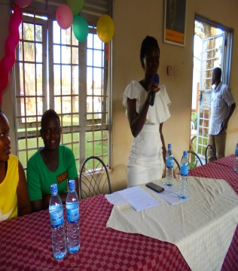 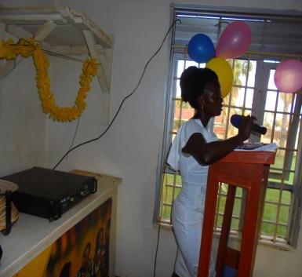

NABWIRE HELLEN

ORGANISING SECRETARY

Nabwire belongs to the flutter team that builds mobile and desktop applications.

She also doubles as the secretary of the project.

She records all data, writes all schedules,proposals,official documents, prepares and keeps all files for the team.

She holds a bachelor’s degree in social arts and social sciences(Makerere university), a certificate in computer studies from the same university.



OTIENO SAMUEL

MEMBER

Samuel holds a diploma in pharmacy( Moi university- Eldoret campus).

He is a member of the flutter team.

He also gives medical advice to the group.

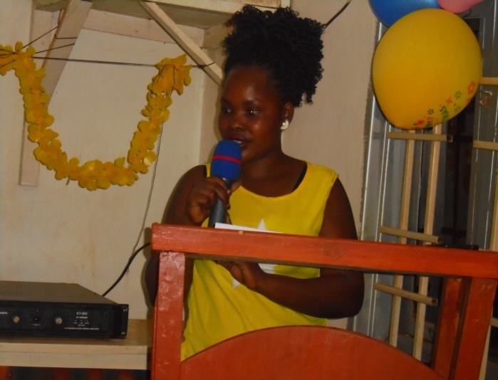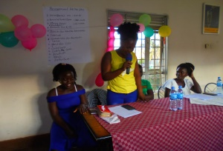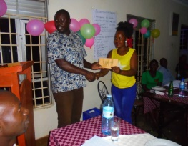

ANYANGO LILIAN

TEAM LEADER – FLUTTER

Anyango is the team leader of the flutter group. She organizes sessions for the flutter group and reports to the overall team leader.

She holds an advanced certificate of education.

She originally had no computer knowledge when she joined Kibalitek in March 2019.

  

AKUKU DOREEN

MEMBER

Doreen is a member of the Java team.

She holds a bachelor’s degree in accounting finance ( Makerere university).

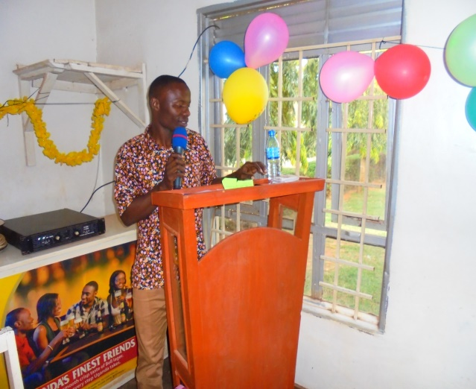

WANYAMA FRANCIS

DESIGN – TECH OFFICER

Francis, is in charge of making design of the skeletons of applications before they are put into the SDKs.

He designs the pictures to be organically used before they are uploaded for use.

He holds a bachelor’s degree in Education with Arts DM ( Kyambogo university).

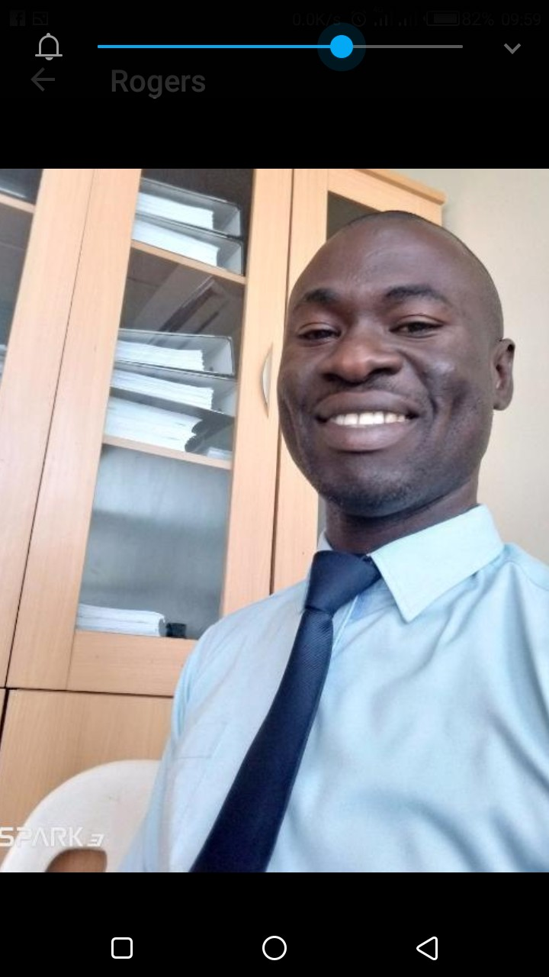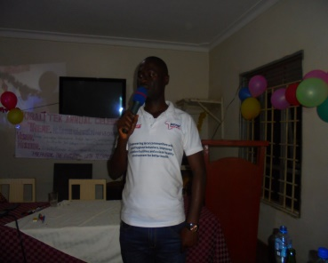

WANDERA ROGERS

PROJECT ACCOUNTANT

Wandera is the accountant and data analyst of the team.

He is in charge of assessing data, compiling books of accounts, preparing schedules and also falls under the flutter team.

He holds a bachelor’s degree in statistics( Kyambogo university).

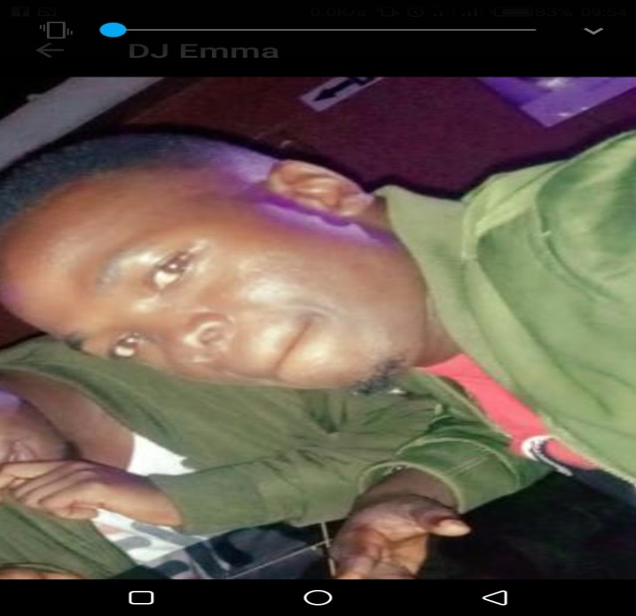

WAFULA EMMANUEL( aka DJ EMMARANX)

MEMBER/ IN CHARGE EVENTS

Emma is in charge of organizing external events and outreaches for the project.

He is also a member of the Java team.

He has an advanced certificate in education and a certificate in computer studies.

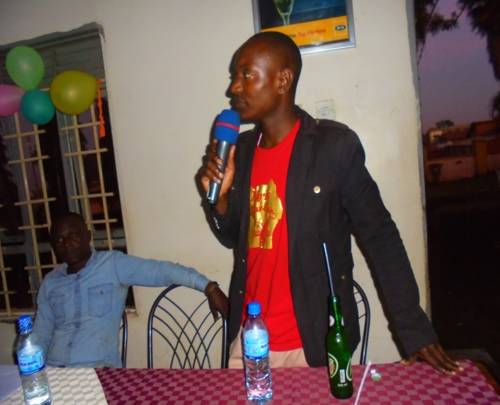

WANYAMA TOM (aka Pastor)

MECHANICAL SPECIALIST

Tom is in charge of all repairs, assembling of machines, activation of computers, connection of gadgets, monitoring of the CCTV and all mechanical related duties of the project.

He also doubles as the team pastor-( leader of spiritual activities).

He holds a bachelor’s degree in computer engineering ( Makerere university).

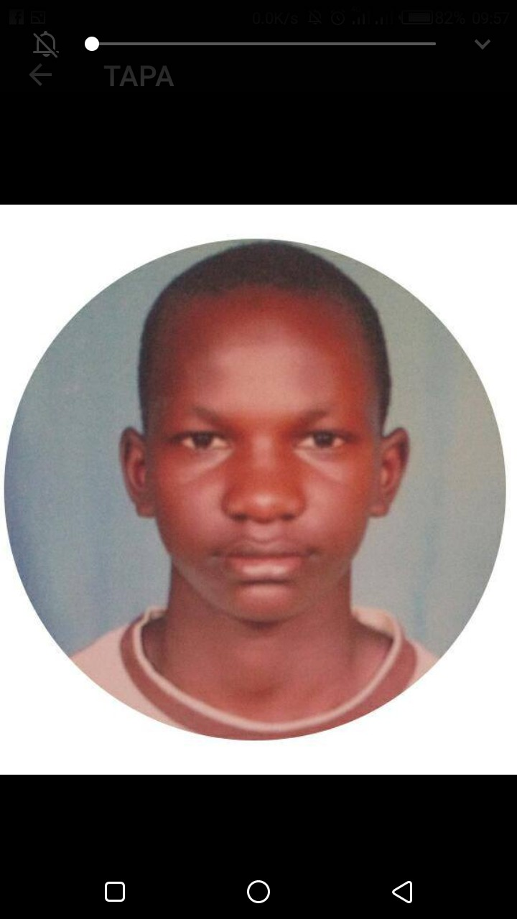

TAPA JOEL

MEMBER

Joel is a member of the project.

He just finished his secondary school education in 2019.

He is has applied for computer science at Makerere university and will be going for the course if he gets fees.



OUMA KEVIN

MEMBER

Kevin is a Member of the flutter team.

He holds an advanced certificate in education.

Originally had no knowledge of computer when he joined kibalitek.



WANDERA JOHN

MEMBER

John is a member of the Java team.

He is a senior four lever.

But has passion for the work and knows some photo shooting and editing.

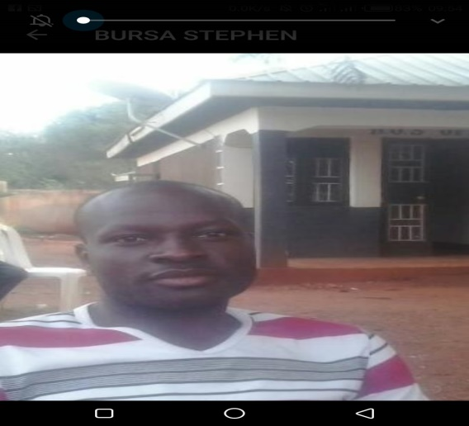

WAFULA STEPHEN

MEMBER

Wafula is a member of the flutter team.

He has a diploma in accounts( UCC Tororo) and also came with basic computer knowledge.

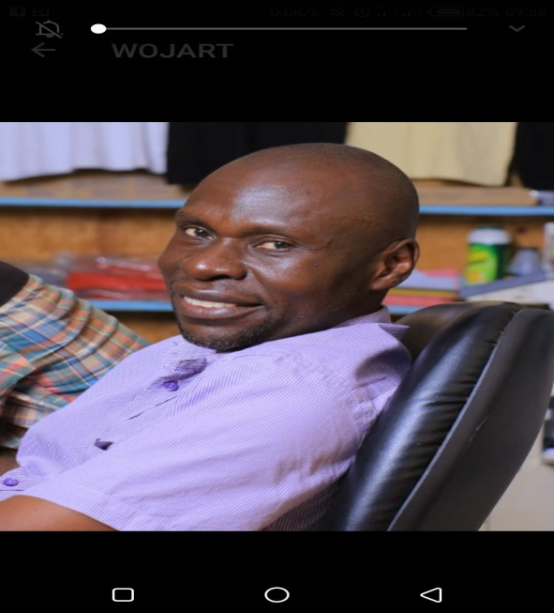

WABWIRE WOJART

MEMBER

Wojart is a member of the flutter team.

He holds a bachelor’s degree in education with artsDM( Makerere university)

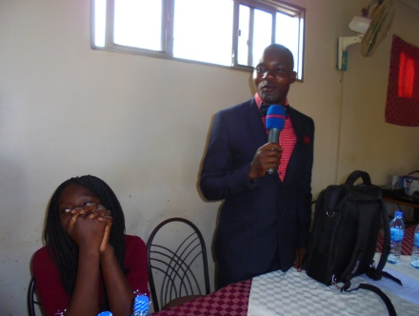 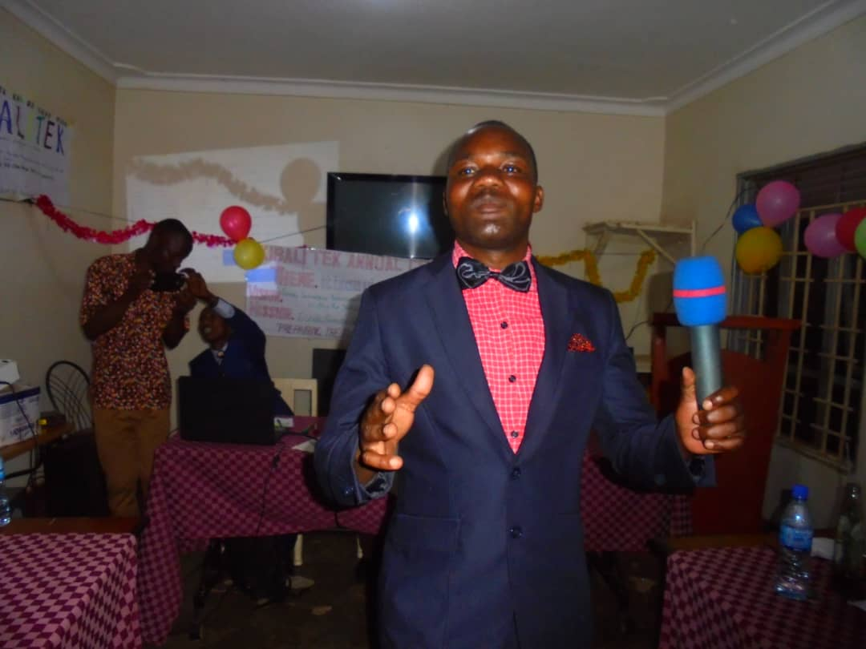

MUKA GODFREY

MEMBER

Gody, is a member of the Java team.

He also writes and sings gospel music.

He is behind the music part of the team.

He joined the team without any computer knowledge.

He is a senior four leaver.

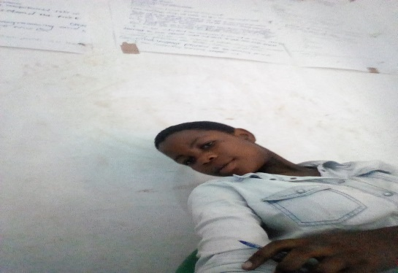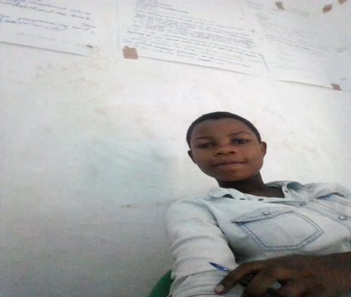

ACHIENG JANET

MEMBER

Janet is a member of flutter team.

She joined the team without any computer knowledge.

She is a primary leaver. The parents did not have money to take her to high school and kibalitek chose to help in skilling her for free.



NAFULA LILIAN

MEMBER

Lilian is a member of the flutter team.

She joined the team without any computer knowledge.

She is a form four leaver.

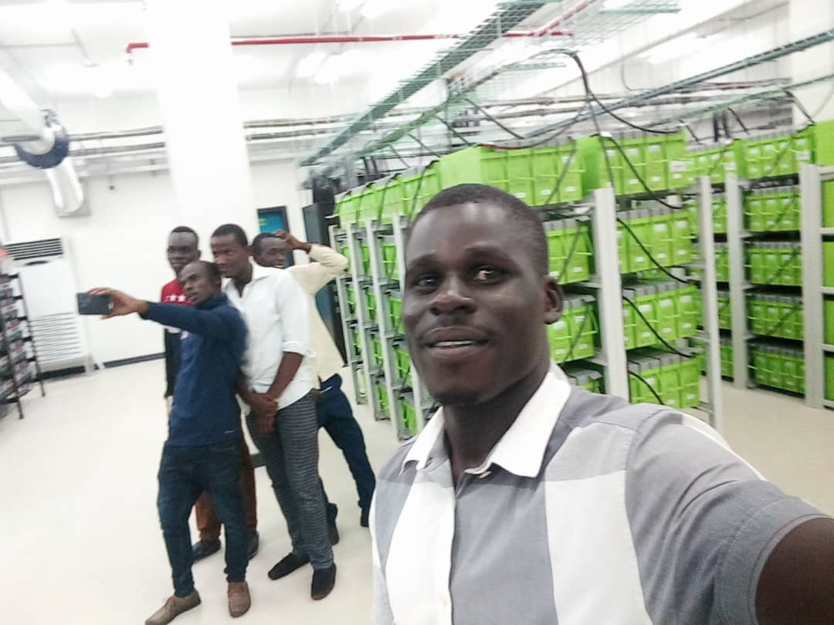

AMAKE LAWRENCE

MEMBER

Lawrence is a member of the flutter team.

He is an under graduate of computer engineering (Busitema university).



OUNDO ASIRO

MEMBER

Asiro is a member of the Java team.

He holds a diploma in business education .

He joined the team with only basic computer knowledge.

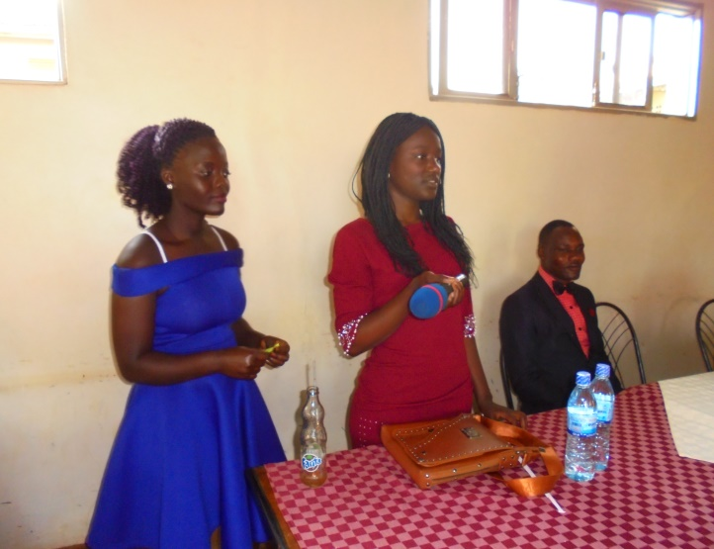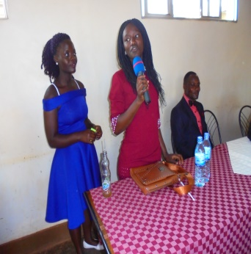

APONDI SARAH

MEMBER

Sarah is a member of the flutter team.

She just completed her high school in 2019.

She joined the team without any computer knowledge.



MAGALA SEMITEO

MEMBER

Semi cordinates with the team on line while in Kampala.

He joins coding sessions on zoom or splash shots.

He woks with a computer engineering firm in Kampala, but being a former student of the CEO at high school, he contributes in the coding time online.

He holds a bachelor’s degree in computer science.

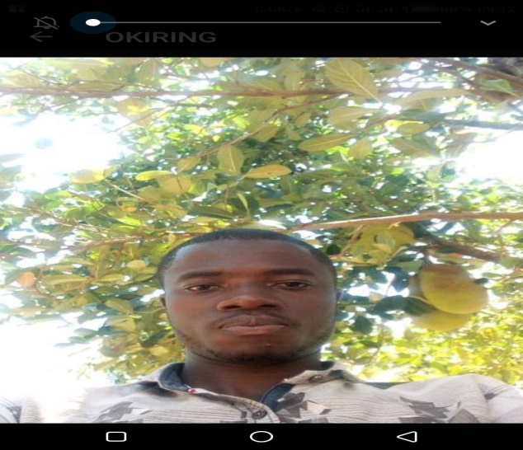

OKIRING SEBASTIANO

MEMBER

Sebastiano is a member of the Java team.

He holds a diploma in comphrehesive nursing.

He also doubles as the team’s clinician.



EBIFA SAMALI

MEMBER

Samali is a member of the Java team.

She holds an advanced certificate of education.

She joined the team without any computer knowledge.

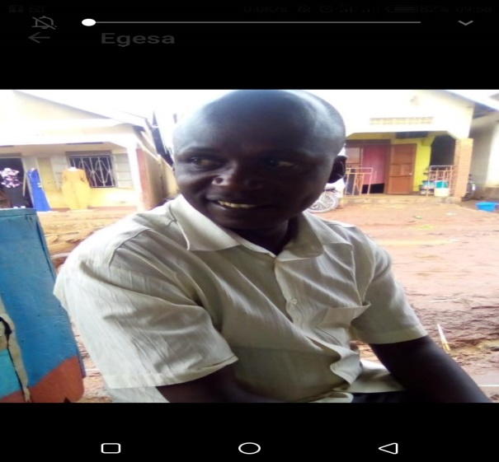

EGESSA CYRUS

MEMBER

Egessa is a member of the flutter team.

He has an advanced certificate in education.

He joined the team without any computer knowledge.



NANDERA TEDDY

MEMBER

Teddy is a member of the Java team.

She holds a diploma in secondary education- BIO/CHEM (Busitema university).

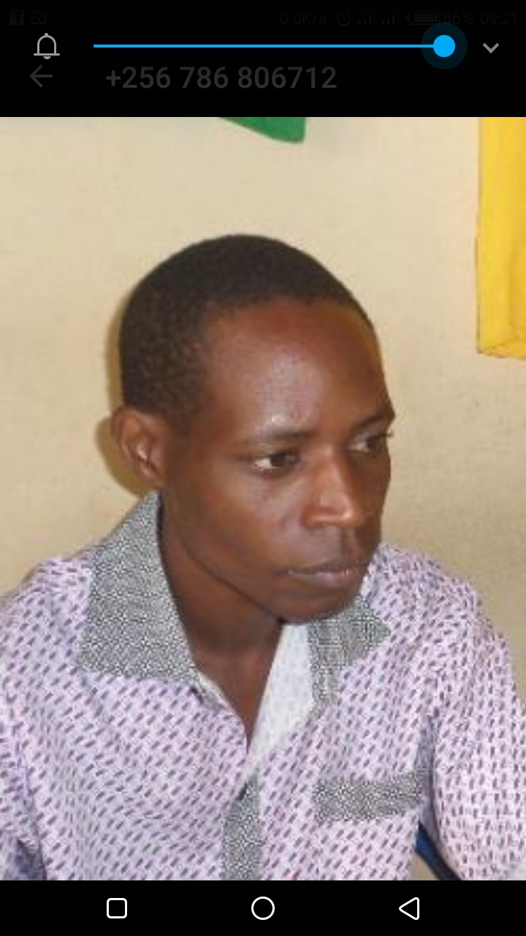

HADULI MARTIN

MEMBER

Haduli is a member of the Java team.

He is also in charge of photo and video editing.

He is a senior four leaver but joined Kibalitek after undergoing a training in photo and video shooting and editing from else where.

MORE

PICTORIALS OF

KIBALITEK.

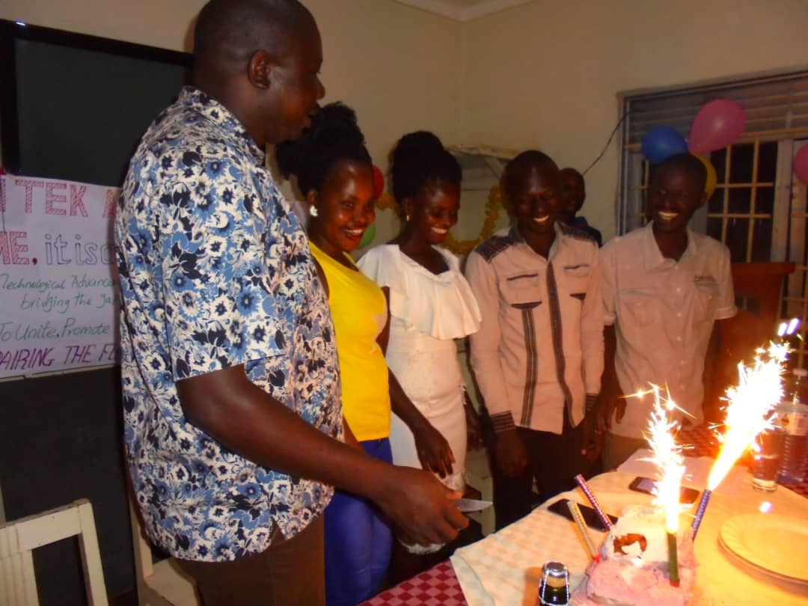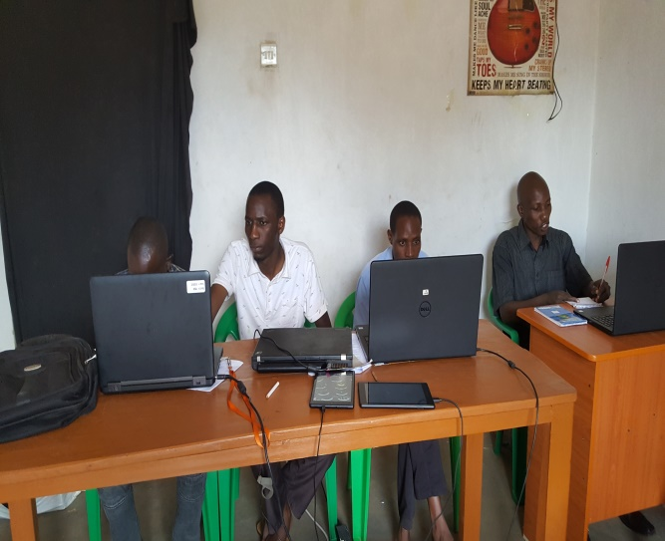

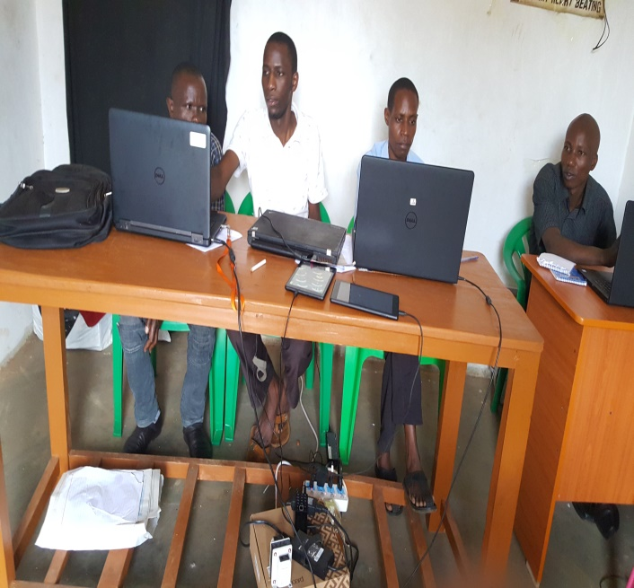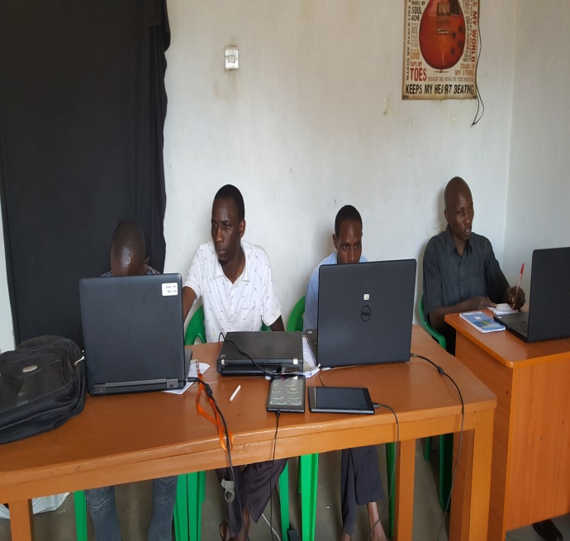

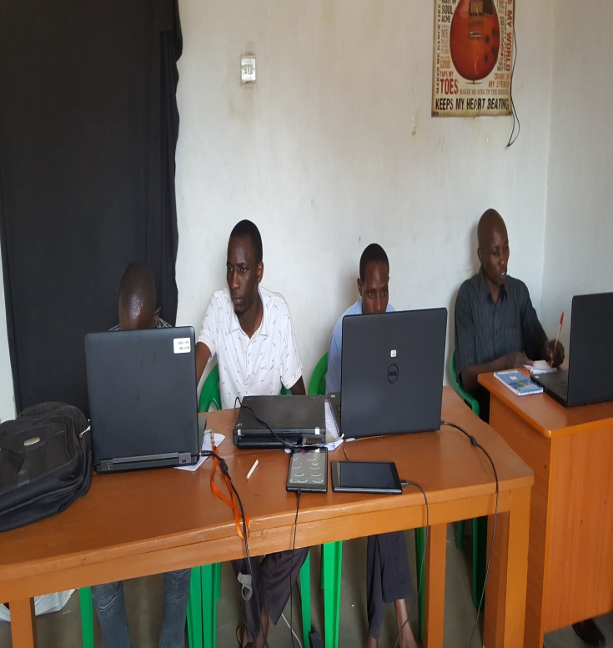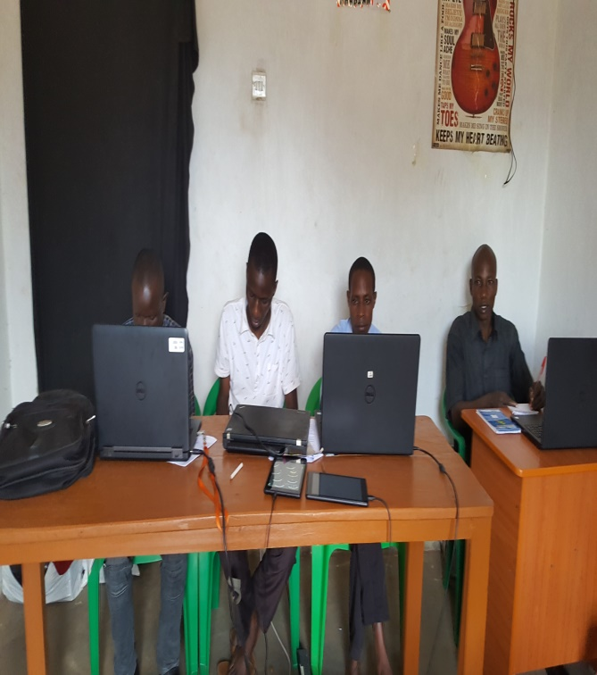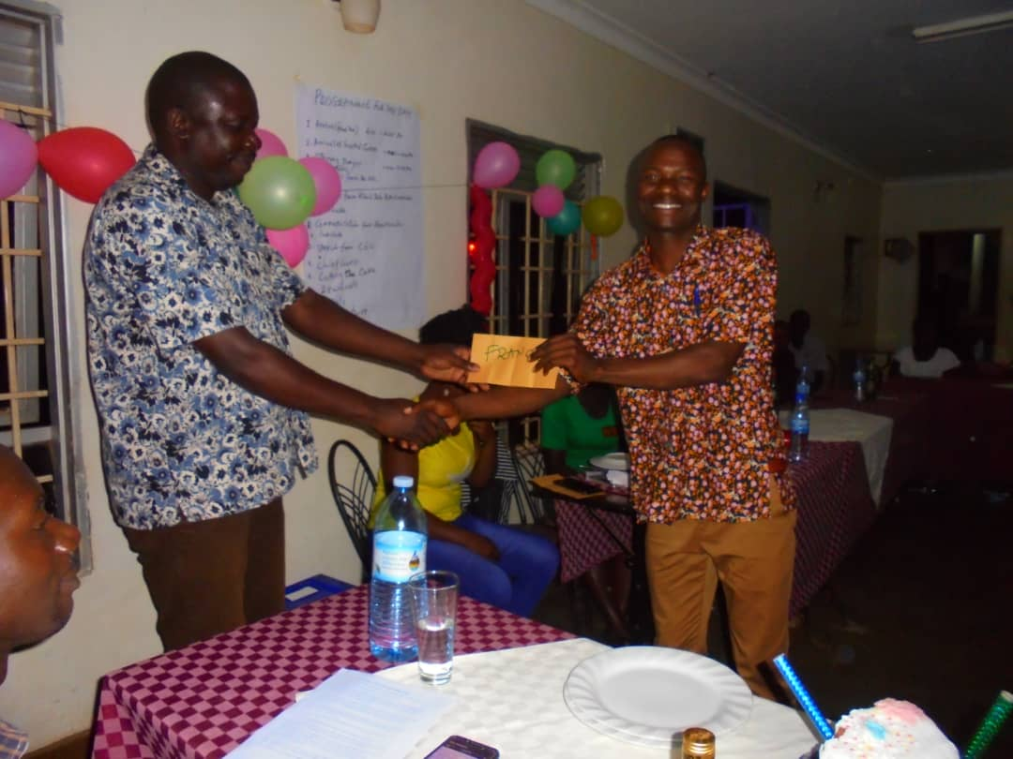 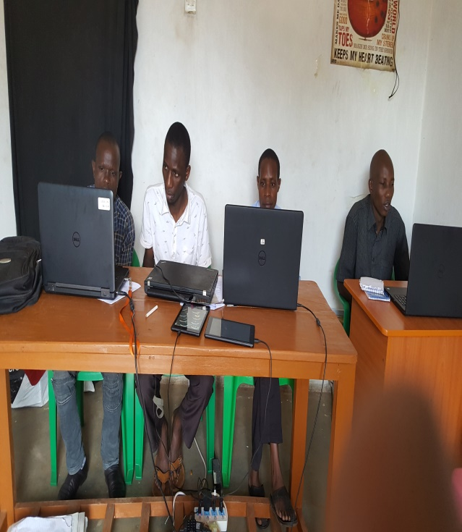

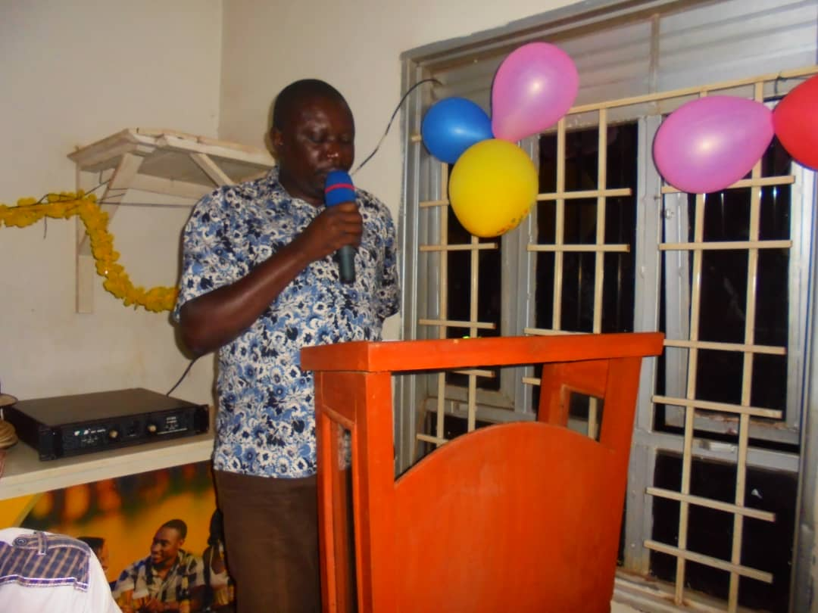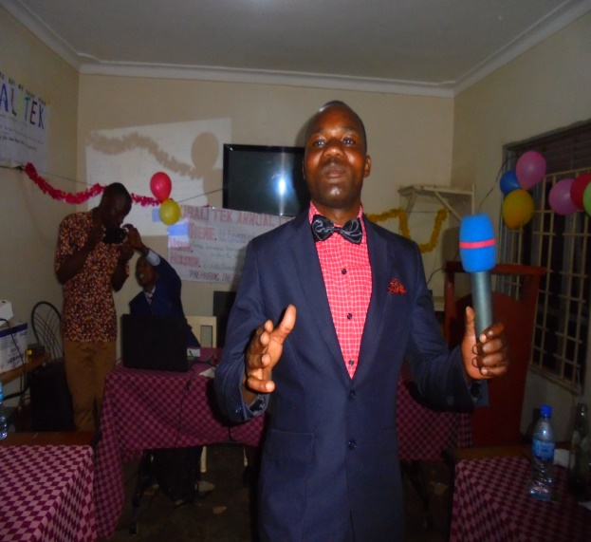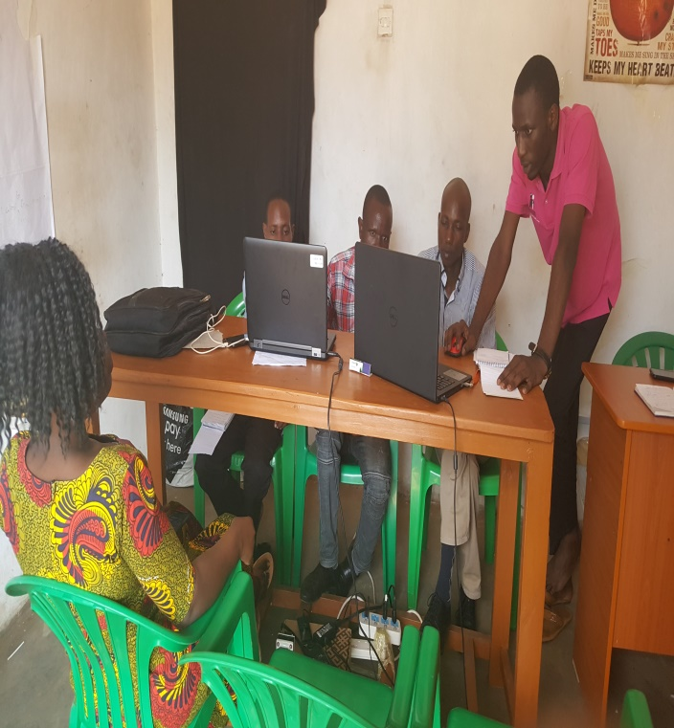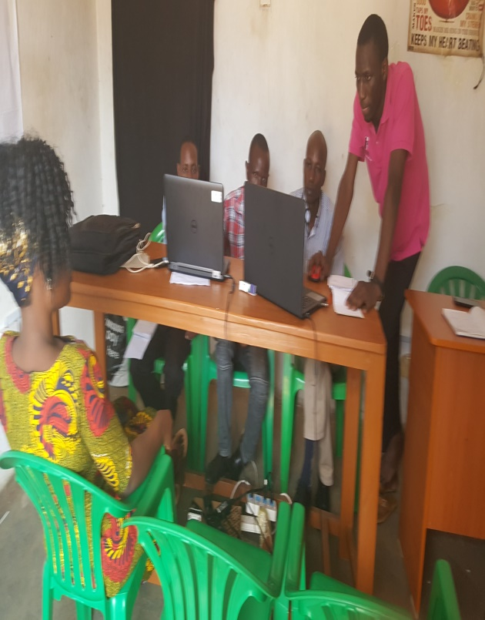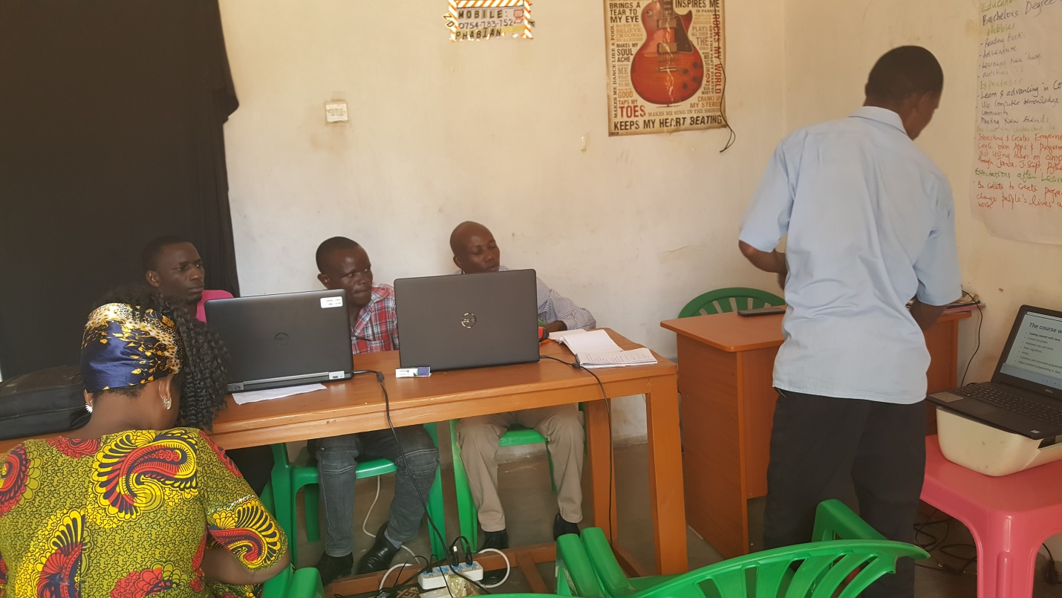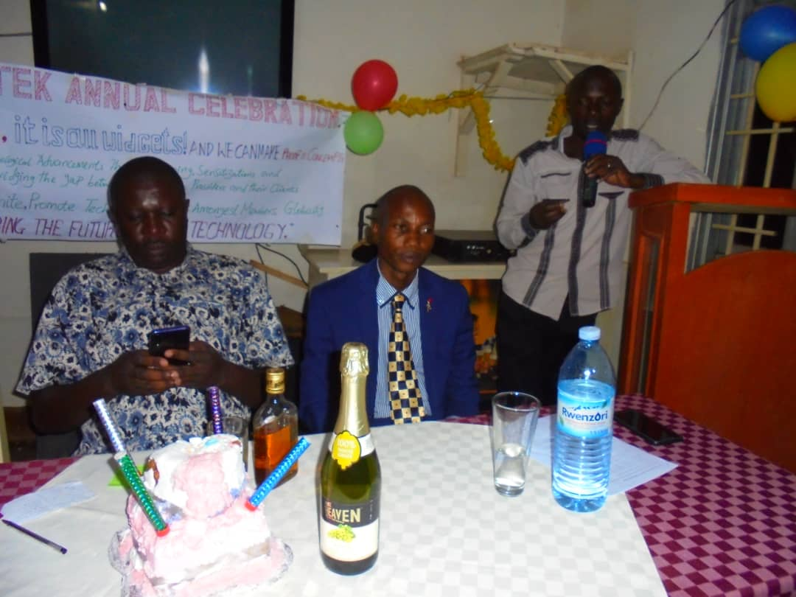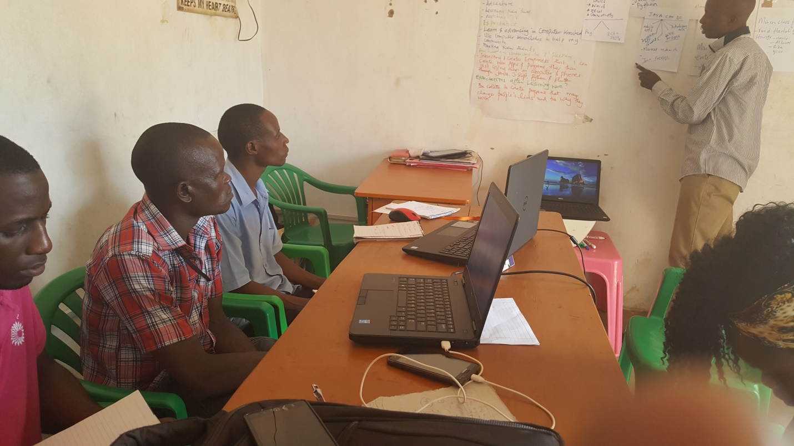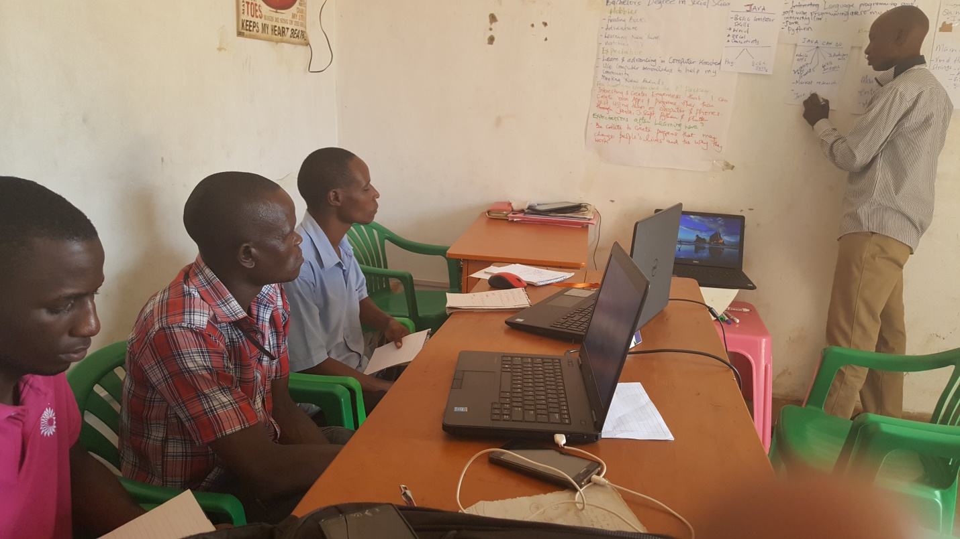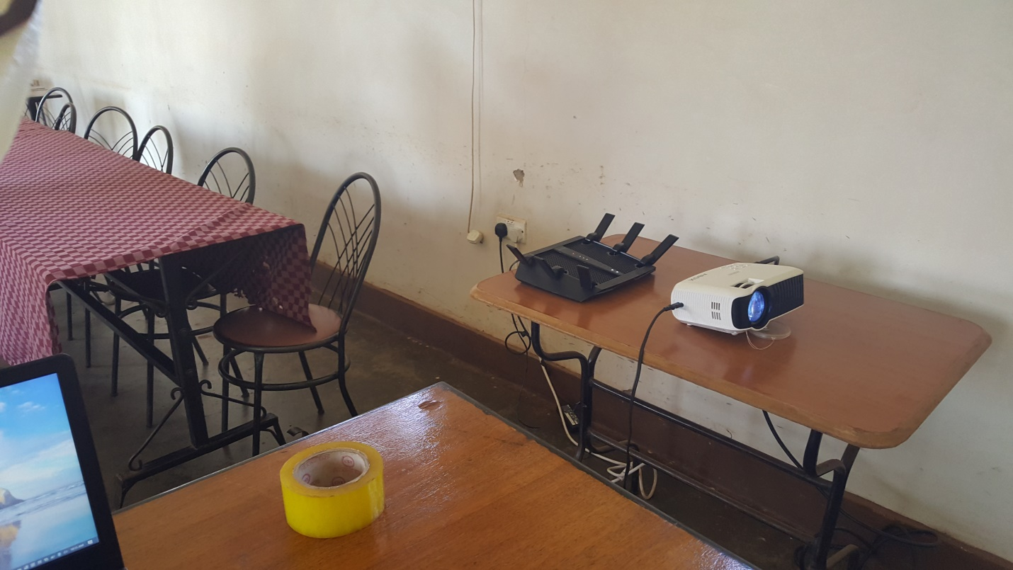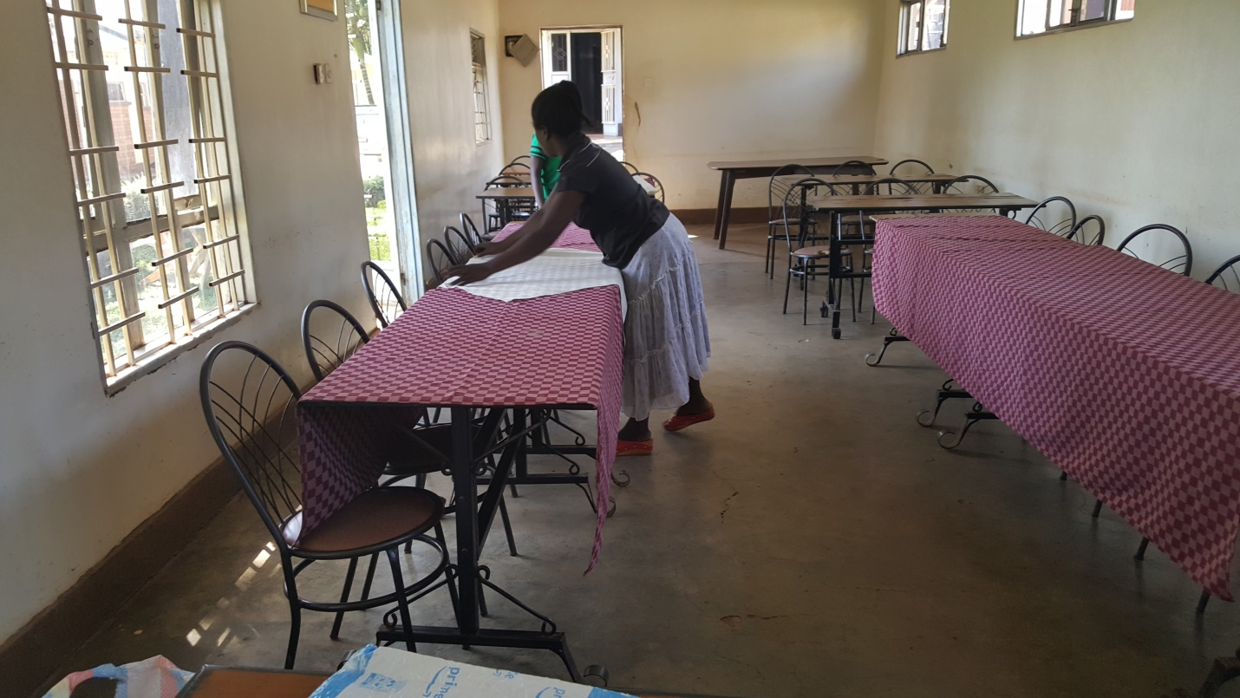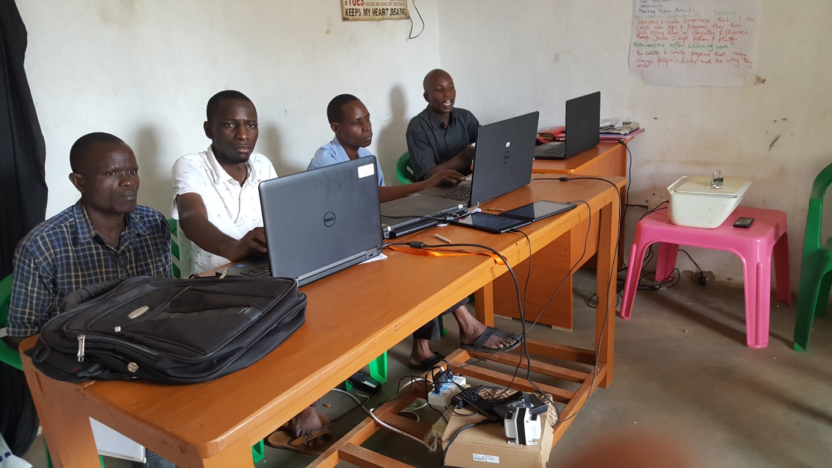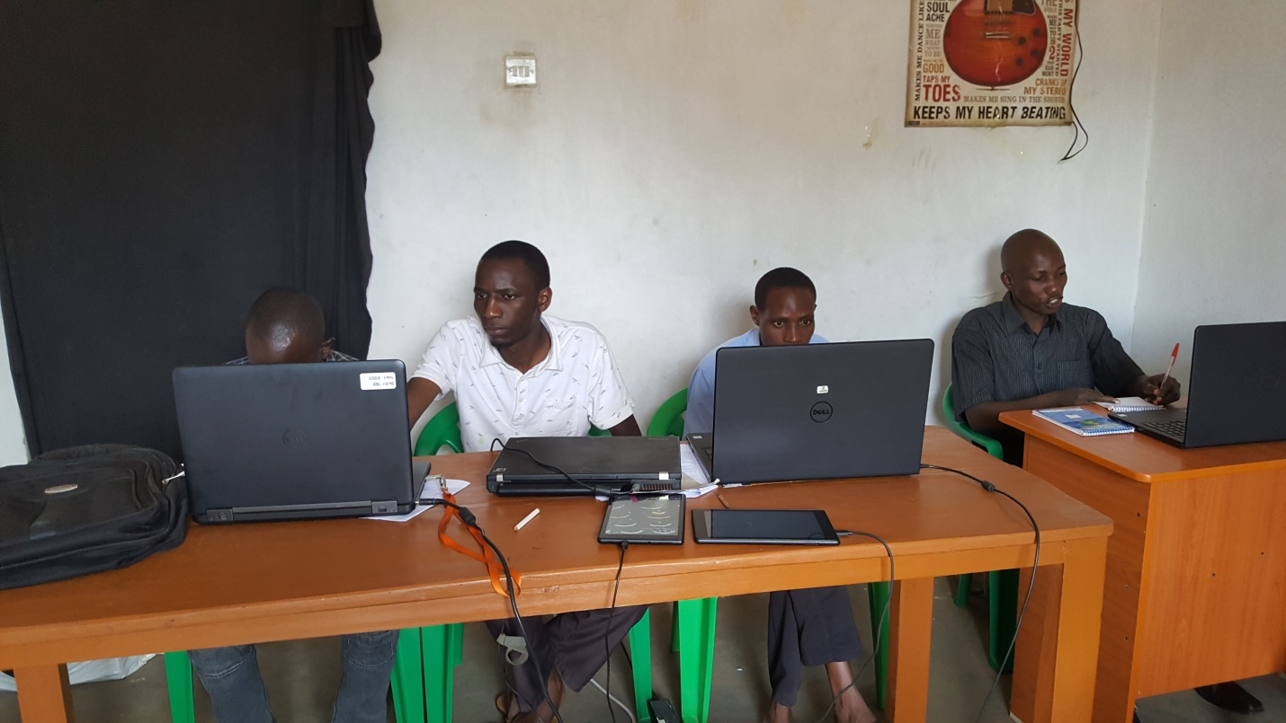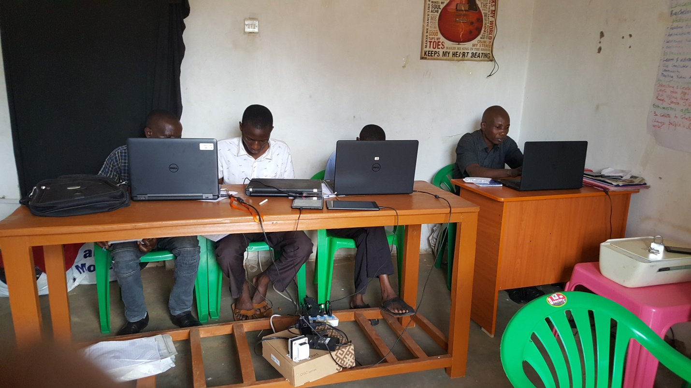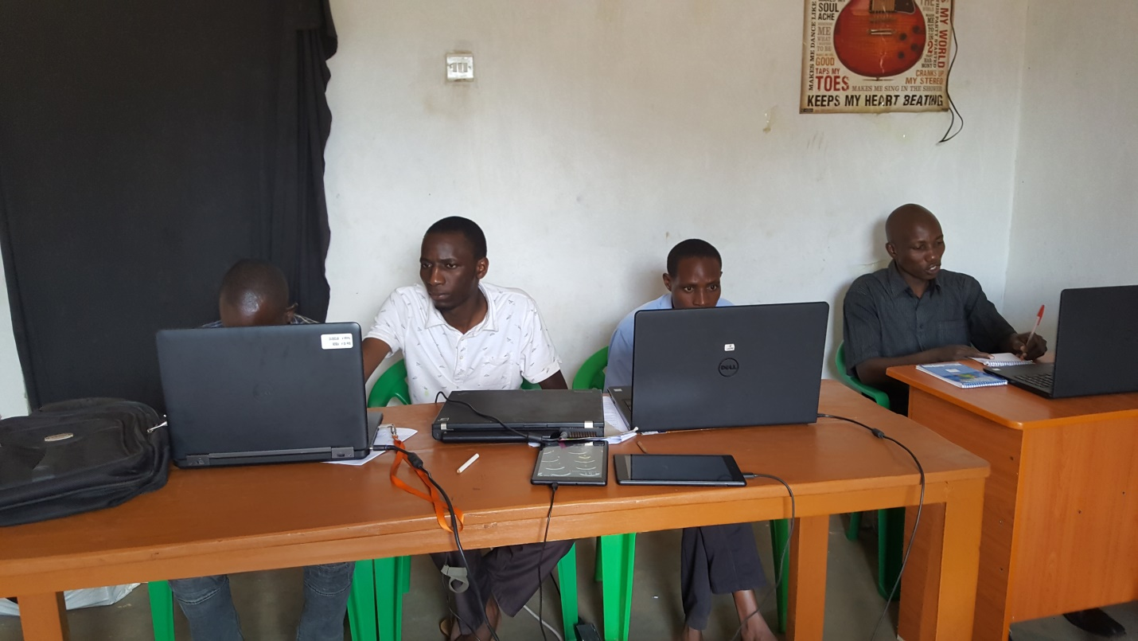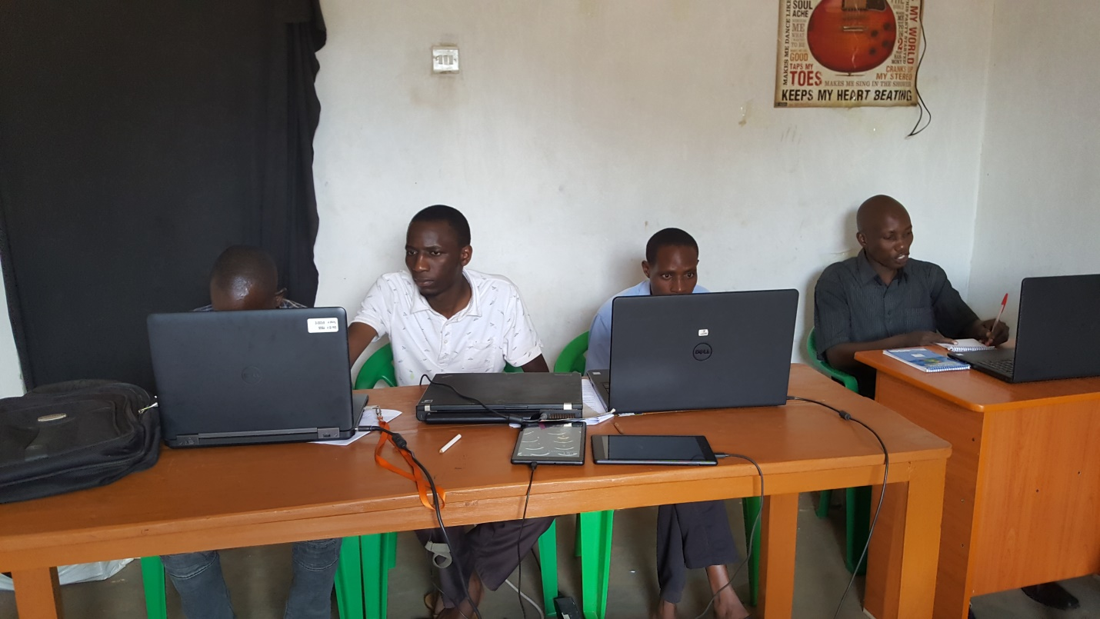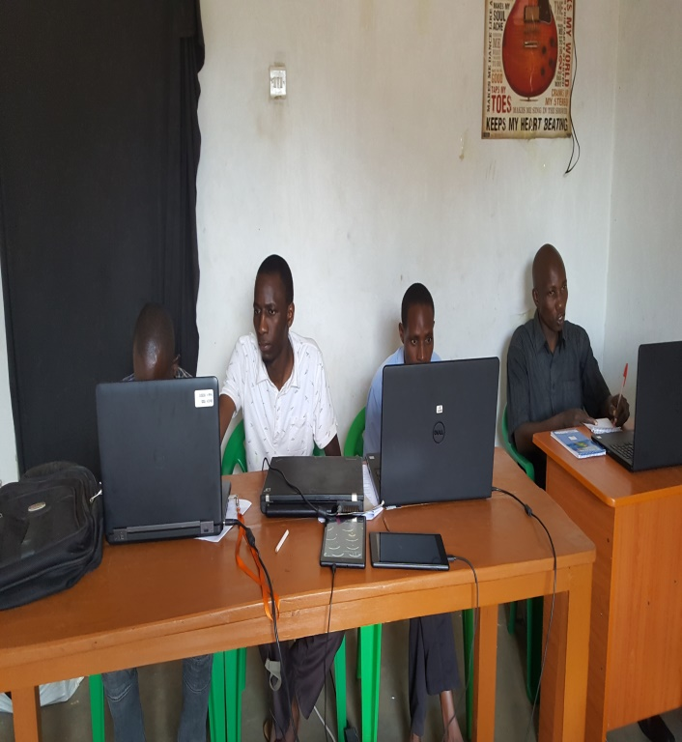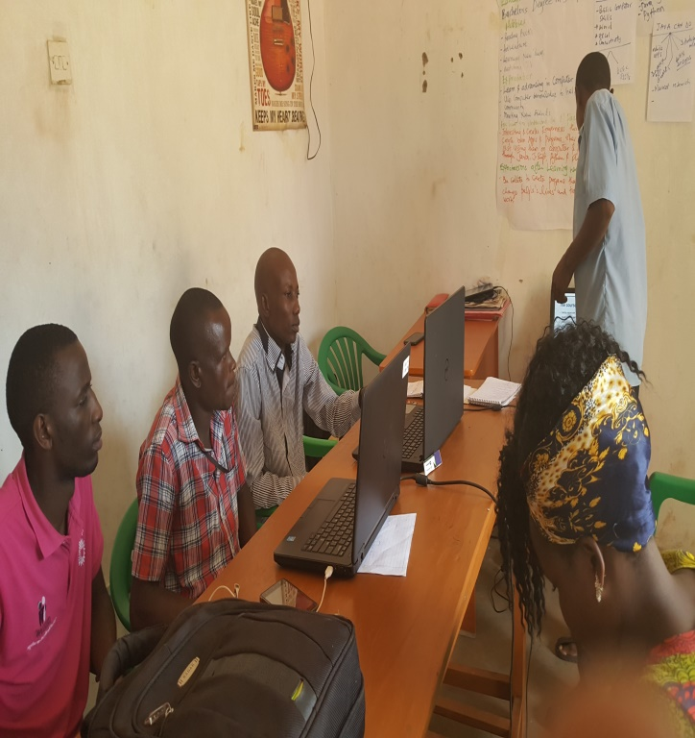

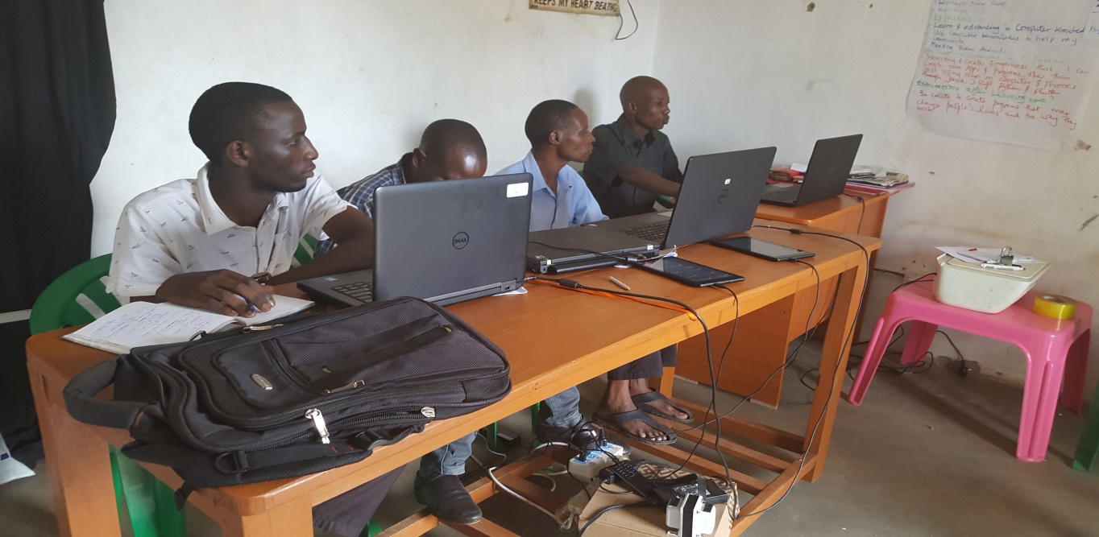 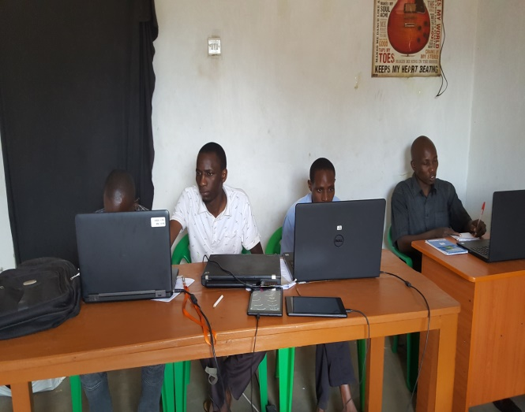 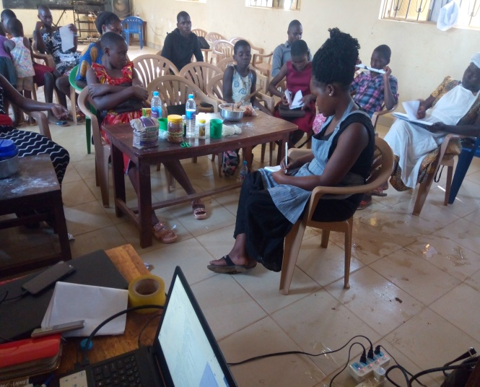

WE WELCOME YOU ALL AT KIBALITEK.

PROFILE FILE 2020